Experiment Number: 8 Date: 25.02.2026

Implementation of Packages in Java

Aim:
Write a Java program to implement built-in, user-defined packages and accessing all classes in a package.

PRE LAB EXERCISE
QUESTIONS
- What is java.util package?
The java.util package in Oracle is one of the most important built-in Java packages.
It provides utility classes and interfaces that help with everyday programming tasks.
It includes:
- Collection Framework classes like ArrayList, LinkedList, HashMap, HashSet, TreeMap
- Utility tools like Scanner, Random, StringTokenizer
- Date and Time classes like Date, Calendar, TimeZone
- Helper functionalities like Timer and TimerTask

- Types of packages in Java:
Java packages are mainly classified into two types:
1. Built-in Packages (Predefined Packages)
These are packages already provided by Java.
Examples:
- java.lang
- java.util
- java.io
- java.sql
- java.awt
2. User-defined Packages
These are packages created by the programmer to organize their own classes and make the code reusable and maintainable.
Example:
package mypackage;

IN LAB EXERCISE
Objective
To learn how to use built-in packages, create user-defined packages, and import classes from a package in Java.
Built-in Packages Overview
Java provides many predefined packages as part of its API. These packages contain ready-made classes that simplify programming. Some commonly used ones are:
• java.lang
Includes fundamental classes required for the Java language itself, such as wrappers for primitive types and classes for mathematical operations. This package is included by default in every Java program.
• java.io
Provides classes that handle different kinds of input and output operations, such as reading and writing files.
• java.util
Offers various utility classes including data structure implementations (like lists, sets, and maps) and classes for working with dates and time.
• java.applet
Contains the classes necessary for developing applets.
• java.awt
Contains classes used for building graphical user interfaces, including elements such as buttons, menus, and other UI components.

Source Code
import java.util.Random;

public class Sample {
public static void main(String[] args) {
// using Random class
Random rand = new Random();
// generates a number between 0–99
int number = rand.nextInt(100);
System.out.println("Random number: " + number);
}
}
Output
Random number: 36
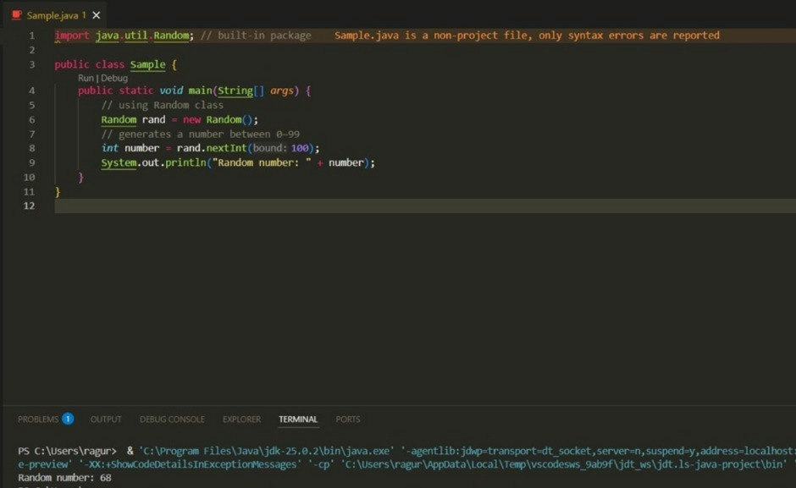

User-defined Packages are the packages that are defined by the user. Source code
package com.myapp;
public class Helper { public static void show() {
System.out.println("Hello from Helper!");
}
}
==To use this in another class== import com.myapp.Helper; public class Test {
public static void main(String[] args) {
Helper.show();
}
}

Output:
Hello from Helper!
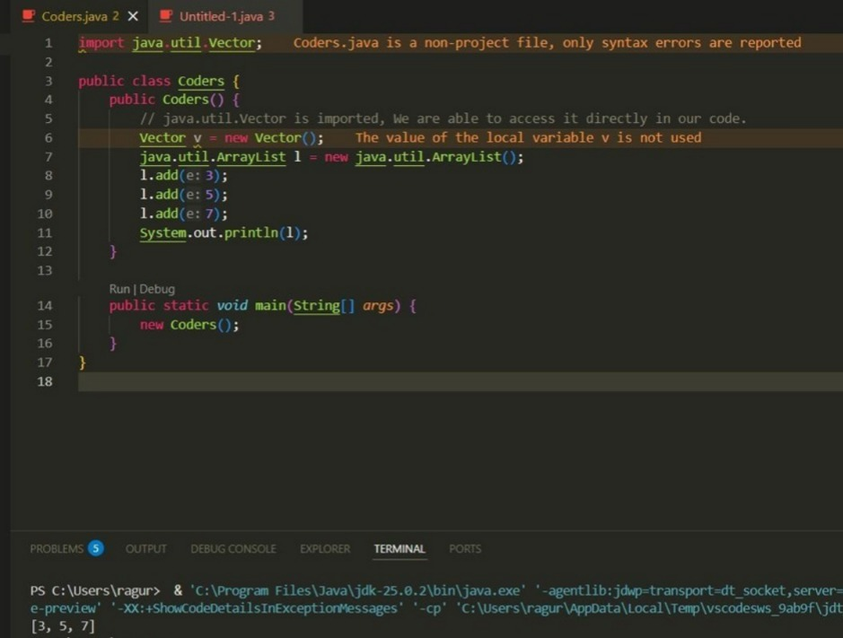
//Importing all classes from a package. Source code
import java.util.Vector; public class Coders { public Coders() {
// java.util.Vector is imported, We are able to access it directly in our code. Vector v = new Vector(); java.util.ArrayList l = new java.util.ArrayList(); l.add(3);
l.add(5);
l.add(7);
System.out.println(l);
}
public static void main(String[] args) { new Coders();
}
}
Output
[3, 5, 7]


POST LAB EXERCISE
- Same class name from different packages?
Yes, Java allows same class names in different packages.
If you use both in one program, you must access them using the fully qualified name:
package1.Student obj1 = new package1.Student();
package2.Student obj2 = new package2.Student();
- Purpose of packages in Java:
The purpose of packages in Java (provided by Oracle) is:
- To group related classes and interfaces
- To avoid naming conflicts
- To improve code organization and readability
- To provide access control
- To make code reusable and maintainable

- Package for GUI window?
In Java, GUI windows are created using:

1. java.awt package
For basic GUI components like Frame, Button, Label.
2. javax.swing package
For advanced GUI components like JFrame, JButton, JPanel.

ASSESSMENT

Description | Max Marks | Marks Awarded
Pre Lab Exercise | 5
In Lab Exercise | 10
Post Lab Exercise | 5
Viva | 10
Total | 30
Faculty Signature

Experiment Number: 9 Date: 25.02.2026

Implementation of a Java Program to import packages using different methods

Aim:
Write a Java program to import packages using different methods for different use cases.

PRE LAB EXERCISE
QUESTIONS
- Importing in Java:
Importing in Java allows you to use classes from other packages in your program.
Example
import java.util.Scanner;
Types of import
- Single class import
import java.util.Random;
- Wildcard import
import java.util.*;
- Default imported package:
In Java (by Oracle), the default automatically imported package is:
java.lang
we don’t need to import it manually because Java includes it in every program.
Example
Classes like String, System, Math, Integer → all come from java.lang.

IN LAB EXERCISE
Objective
To learn how to create Java packages in multiple ways, place classes inside them, and import those packages into other programs for execution.
Problem
Define a package named ‘useFul’ with a class names ‘UseMe’ having following methods:
- area()- To calculate the area of given shape.
- salary()- To calculate the salary given basic Salary,da,hRA.
- percentage()-To calculate the percentage given total marks and marks obtained.
- Develop a program named ‘Package Use’ to import the above package ‘useFul’ and use the method area().
- Develop a program named ‘manager’
Source Code
//Package Creation: package useFull; import java.util.*; public class UseMe
{
Scanner obj=new Scanner(System.in); public static void area()
{
class method{ void aos(int a)
{
System.out.print("\nArea of square with length "+a+" is "+(a*a));
}
void aor(int a,int b)
{
System.out.print("\nArea of reactangle with dimensions "+a+" & "+b+" is "+(a*b));
}
void aoc(int r)
{
double a=3.14*r*r;
}
System.out.print("\nArea of circle with radius "+r+" is "+a);
}
void aot(int a,int b)
{
float ar=(a*b)/2;
System.out.print("\nArea of triangle with dimensions "+a+" &"+b+" is "+ar);
} }
Scanner obj=new Scanner(System.in); method m=new method();
System.out.print("\n1.Square\n2.Rectangle\n3.Circle\n4.Triangle\nSelect the shape\n"); int ch=obj.nextInt();
UseMe u=new UseMe(); switch(ch)
{
case 1:System.out.print("\nEnter the length of side of square : "); int s=obj.nextInt();m.aos(s); break; case 2:System.out.print("\nEnter the dimensions of rectangle : "); int l=obj.nextInt(); int b=obj.nextInt(); m.aor(l,b); break; case 3:System.out.print("\nEnter the radius of circle : "); int r=obj.nextInt(); m.aoc(r); break; case 4:System.out.print("\nEnter the dimensions of triangle : "); int ba=obj.nextInt(); int w=obj.nextInt(); m.aot(ba,w); break; } }
public void salary()
{
int ba,da,hra;
System.out.print("\nEnter the basic salary : "); ba=obj.nextInt();
System.out.print("\nEnter the dearness allowance :"); da=obj.nextInt();
System.out.print("\nEnter the house rent allowance : "); hra=obj.nextInt();
System.out.print("\nThe total Gross salary of employee is : "+(ba+da+hra));
}
public void percentage()
{
int n,sum=0; float p;
System.out.print("\nEnter the total number of subjects : "); n=obj.nextInt(); int m[]=new int[n];
System.out.print("\nEnter the marks of "+n+" subjects : "); for(int i=0;i<n;i++)
{
m[n]=obj.nextInt();
}
for(int i=0;i<n;i++)
{
sum=sum+m[i];
}
p=sum/n;
{
System.out.print("\nPercentahe of student : "+p);
}
}
}
//Package Implementation-1: import useFull.UseMe; class packageUse
{
public static void main(String args[])
{
UseMe o=new UseMe();o.area();
}
}

Output javac packageUse.java java packageUse
- Square
- Rectangle
- Circle
- Triangle
Select the shape
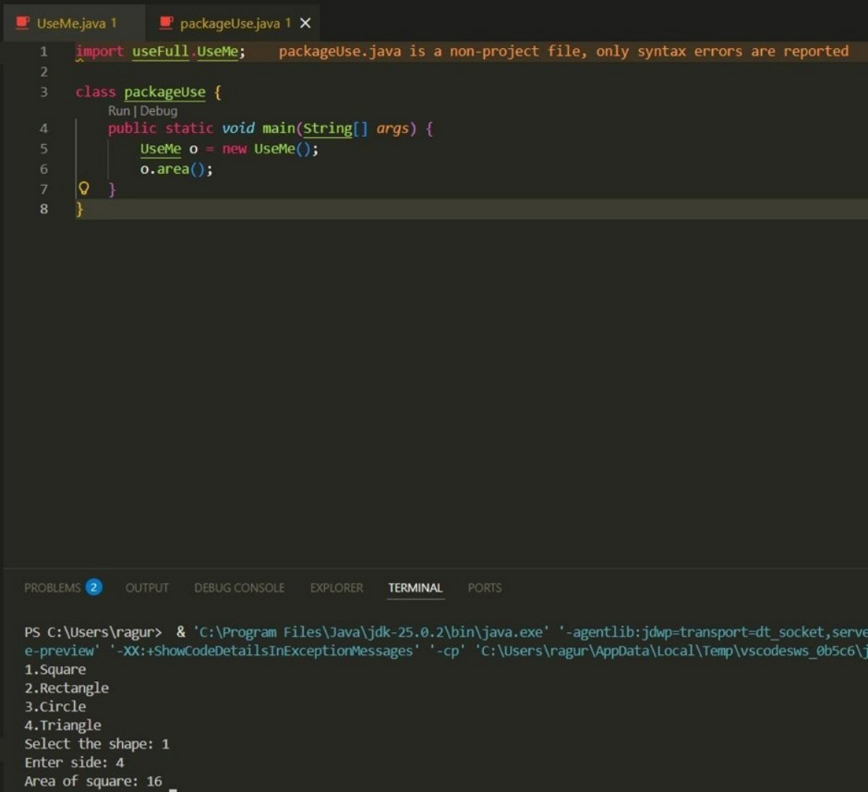

2
Enter the dimensions of the rectangle: 10 15 Area of the rectangle with dimensions 10&15 is 150 //Package Implementation-2:
import useFull.UseMe; class manager
{
public static void main(String args[])
{
UseMe obj=new UseMe();obj.salary();
}
}

Output javac manager.java java manager

Enter the basic salary: 100000
Enter the dearness allowance: 5000
Enter the house rent allowance: 2000
The total Gross salary of employee is: 107000
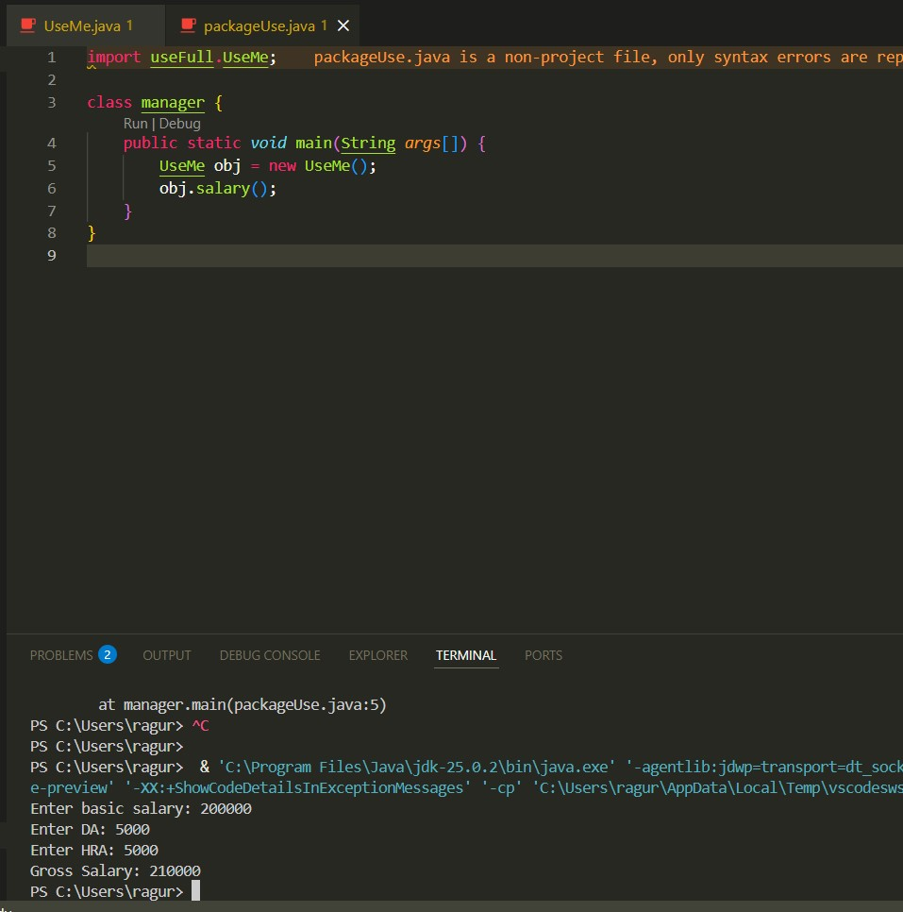
POST LAB EXERCISE
- Difference between java.lang and java.util:
1. java.lang
- This package is automatically imported in every Java program.
- It contains core language classes like String, System, Math, Object, wrapper classes, etc.
- Used for basic and essential functionalities.
2. java.util
- This package must be imported manually using import java.util.*;
- It contains utility classes and data structures like ArrayList, HashMap, Date, Scanner, Random, etc.
- Used for collections, input handling, date/time, and utility operations.

- Subpackages of java.util:
In Java (by Oracle), the main subpackages under java.util are:
- java.util.concurrent – classes for multithreading and concurrency
- java.util.regex – classes for regular expressions
- java.util.function – functional interfaces used in lambda expressions
- java.util.stream – stream API for functional-style operations
- java.util.logging – logging framework
- java.util.prefs – preference and configuration storage
- java.util.zip – classes for compression (ZIP, GZIP)

ASSESSMENT

Description | Max Marks | Marks Awarded
Pre Lab Exercise | 5
In Lab Exercise | 10
Post Lab Exercise | 5
Viva | 10
Total | 30
Faculty Signature

